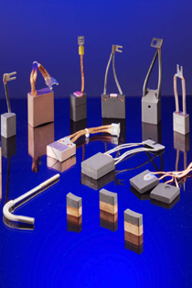
Carbon Brushes - is somewhat of a loose term, it generally designates any motor or generator brush with carbon in its composition. This carbon may be in the form of coke, lamp black or graphite, no matter what quantities of other materials may be present it is still called a “Carbon Brush”
Classes of Brush grades
- Natural Graphite Class
Natural graphite which undergoes prolonged heat treatment, the properties obtained allow them to be used at the highest surface speeds in present use. They can result in more comm wear than electrographite grades but have long life and operational stability when used in applications specifically suited

- Electrographite Class
The most widely used, carbon is converted into graphite by heat treatment @ a temperature of 2500°C, it has excellent high thermal & electrical conductivity & is very resistant to burning consequently these grades are capable of heavy overloads. They are of a high purity, resulting in low collector wear.

- Metal-Graphite Class –
These grades contain varying proportions of copper or silver & graphite, the graphite is to limit the rate of wear of the collector. The lowest rate of wear contains the highest amount of graphite which current density & cooling conditions will permit.
DC machines of slow speed and low or very low voltage. Bronze rings of slow speed asynchronous motors, heavily loaded, with or without brush lifting gear. Rings of synchronous motors of low or medium speed. High current collection on rotating collectors, special machines, slip-ring assemblies.

- Silver-Graphite Class –
Silver graphite materials are mainly used on Tachogenerators, or for measuring purposes, or on ships earthing applications.

- Resin-Bonded Class
These grades are based on graphite, but have a resin bond. This type of bond produces a high electrical resistance which endows them with extremely good commutating ability. Their current carrying capacity is, however, limited.

We supply carbon brushes for major applications & industries such as Wide range of Slip ring & Commutator Motors, Steel Industries, Cement Industries, Mining Industries, Crane Applications, Fork Lifts, Steam / Hydro Exciters, Generators & Motors for Pulp & Paper Mills, Shipping, Wind Generation, Power Generators, Plastic Industries and all types of A.C and D.C Motors.

